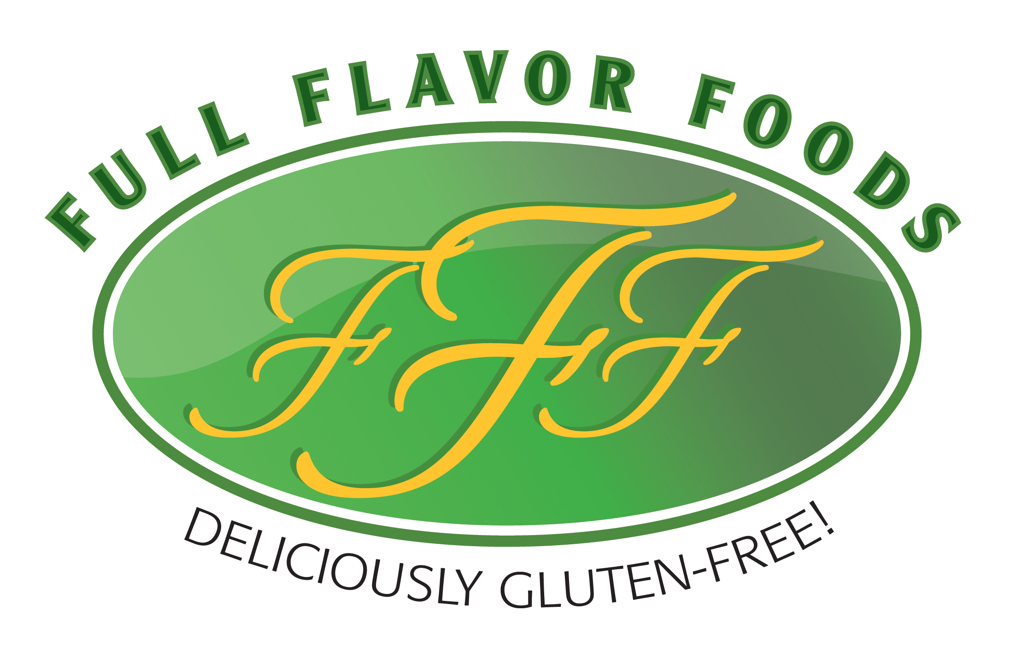
Gluten-Free Soups, Sauces, Gravies

0 Trans Fats * No MSG * Nut Free * Egg Free * No Artificial Colors, Flavors or Preservatives

Garlic Lemon Dill Salmon
Featuring Full Flavor Foods Cream Sauce
Recipe by Kari Hauger at Minneceliac.com

Ingredients

- 4 salmon filets, fresh or frozen
- 1 packet Full Flavor Foods Cream Sauce mix
- 1 ½ cups cool water
- 2 cloves garlic, finely minced
- 1 teaspoon black pepper
- ½ teaspoon salt
- 2 tablespoons freshly squeezed lemon juice
- 1 Tablespoon fresh dill, chopped
- 2 tablespoons olive oil

Instructions

- If the salmon you are using is frozen, follow the directions on the package to properly thaw them out.
- Preheat oven to 350° Fahrenheit. Line a baking sheet with parchment paper.
- Dry the salmon by patting with a paper towel. Drizzle with olive oil and season with salt and paper. Place one lemon slice on top of each salmon filet.
- Bake salmon on the baking sheet for about 15 minutes until the fish is flaky. If you're testing the temperature with a thermometer then you're looking to be at 145°.
- While the salmon is baking, start your cream sauce. Heat 2 cloves of finely minced garlic in a tablespoon of olive oil in a saucepan. When it starts to soften, prepare your cream sauce by adding 1 ½ cups cool water with the dry Full Flavor Foods cream sauce mix in a saucepan. Whisk until it starts to thicken.
- Add in lemon juice, pepper and fresh dill. If you don't have fresh dill, used dried.
- Heat on low for a few minutes to get all the flavors combined.
- Spoon the cream sauce over the salmon. Garnish with a lemon slice and sprinkle with dill.

For more recipe ideas and celiac support, Visit Kari Hauger at www.minneceliac.com or email her at kari@minneceliac.com

5197 Gallagher Blvd., Whitmore Lake, MI 48189 www.forfullflavor.com (269)795-2000

